Level in DFD
In Software engineering DFD(data flow diagram) can be drawn to represent the system of different levels of abstraction. Higher-level DFDs are partitioned into low levels-hacking more information and functional elements. Levels in DFD are numbered 0, 1, 2 or beyond. Here, we will see mainly 3 levels in the data flow diagram, which are: 0-level DFD, 1-level DFD, and 2-level DFD.
Data Flow Diagrams (DFD) are graphical representations of a system that illustrate the flow of data within the system. DFDs can be divided into different levels, which provide varying degrees of detail about the system. The following are the four levels of DFDs:
- Level 0 DFD: This is the highest-level DFD, which provides an overview of the entire system. It shows the major processes, data flows, and data stores in the system, without providing any details about the internal workings of these processes.
- Level 1 DFD: This level provides a more detailed view of the system by breaking down the major processes identified in the level 0 DFD into sub-processes. Each sub-process is depicted as a separate process on the level 1 DFD. The data flows and data stores associated with each sub-process are also shown.
- Level 2 DFD: This level provides an even more detailed view of the system by breaking down the sub-processes identified in the level 1 DFD into further sub-processes. Each sub-process is depicted as a separate process on the level 2 DFD. The data flows and data stores associated with each sub-process are also shown.
- Level 3 DFD: This is the most detailed level of DFDs, which provides a detailed view of the processes, data flows, and data stores in the system. This level is typically used for complex systems, where a high level of detail is required to understand the system. Each process on the level 3 DFD is depicted with a detailed description of its input, processing, and output. The data flows and data stores associated with each process are also shown.
The choice of DFD level depends on the complexity of the system and the level of detail required to understand the system. Higher levels of DFD provide a broad overview of the system, while lower levels provide more detail about the system’s processes, data flows, and data stores. A combination of different levels of DFD can provide a complete understanding of the system.
- 0-level DFD: It is also known as a context diagram. It’s designed to be an abstraction view, showing the system as a single process with its relationship to external entities. It represents the entire system as a single bubble with input and output data indicated by incoming/outgoing arrows.
- 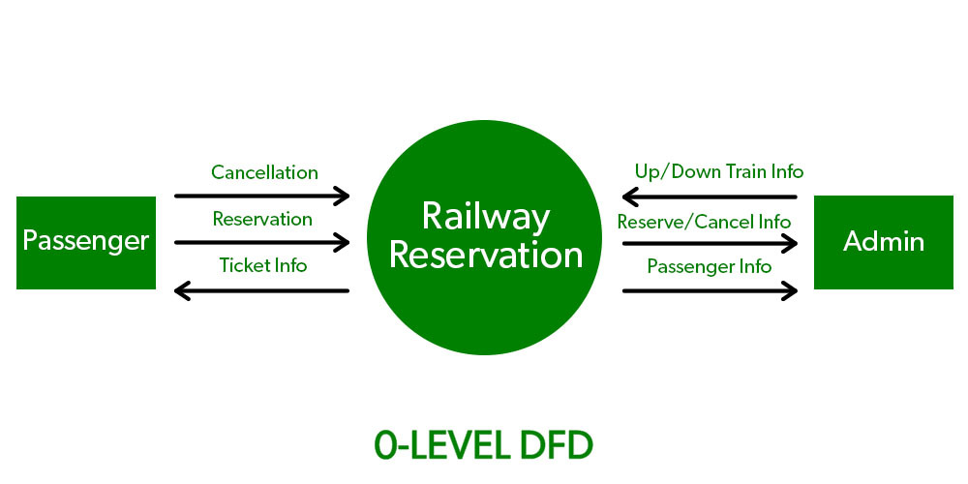1-level DFD: In 1-level DFD, the context diagram is decomposed into multiple bubbles/processes. In this level, we highlight the main functions of the system and breakdown the high-level process of 0-level DFD into subprocesses.
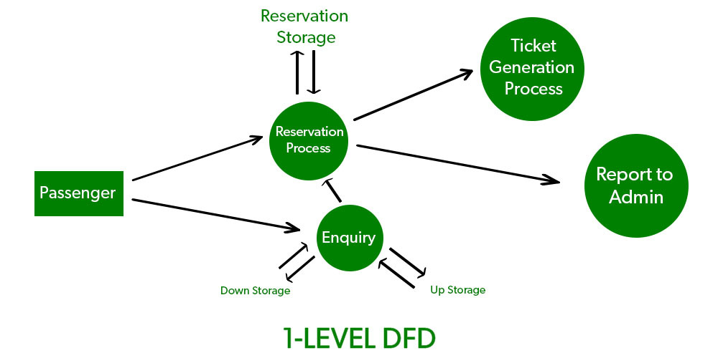
- 2-level DFD: 2-level DFD goes one step deeper into parts of 1-level DFD. It can be used to plan or record the specific/necessary detail about the system’s functioning.
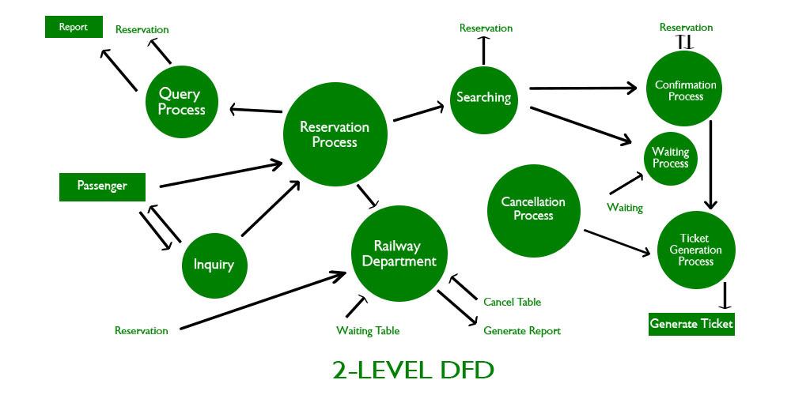

Advantages of using Data Flow Diagrams (DFD) include:
- Easy to understand: DFDs are graphical representations that are easy to understand and communicate, making them useful for non-technical stakeholders and team members.
- Improves system analysis: DFDs are useful for analyzing a system’s processes and data flow, which can help identify inefficiencies, redundancies, and other problems that may exist in the system.
- Supports system design: DFDs can be used to design a system’s architecture and structure, which can help ensure that the system is designed to meet the requirements of the stakeholders.
- Enables testing and verification: DFDs can be used to identify the inputs and outputs of a system, which can help in the testing and verification of the system’s functionality.
- Facilitates documentation: DFDs provide a visual representation of a system, making it easier to document and maintain the system over time.

Disadvantages of using DFDs include:
- Can be time-consuming: Creating DFDs can be a time-consuming process, especially for complex systems.
- Limited focus: DFDs focus primarily on the flow of data in a system, and may not capture other important aspects of the system, such as user interface design, system security, or system performance.
- Can be difficult to keep up-to-date: DFDs may become out-of-date over time as the system evolves and changes.
- Requires technical expertise: While DFDs are easy to understand, creating them requires a certain level of technical expertise and familiarity with the system being analyzed.
- Overall, the benefits of using DFDs outweigh the disadvantages. However, it is important to recognize the limitations of DFDs and use them in conjunction with other tools and techniques to analyze and design complex software systems.

Data Flow Diagram Examples
1. Context data flow diagram: definition and example with explanation
When it comes to simple data flow diagram examples, context one has the top place.
Context data flow diagram (also called Level 0 diagram) uses only one process to represent the functions of the entire system.

It does not go into details as marking all the processes.
The purpose is to express the system scope at a high level as well as to prevent users from deep down into complex details.
The major advantage of context DFD is simplicity.
Key context DFD characteristics:
- Simple to draw.
- No need of technical knowledge to understand it.
- Shows the system boundaries.
Steps for creating a context DFD:
- Step1: Define the process.
- Step2: Create a list of all external entities (all people and systems).
- Step3: Create a list of the data flows.
- Step4: Draw the diagram.
Let’s illustrate the things with a context data flow diagram example.
Below is shown a simple context DFD drawn for a Clothes Ordering System and explanation.
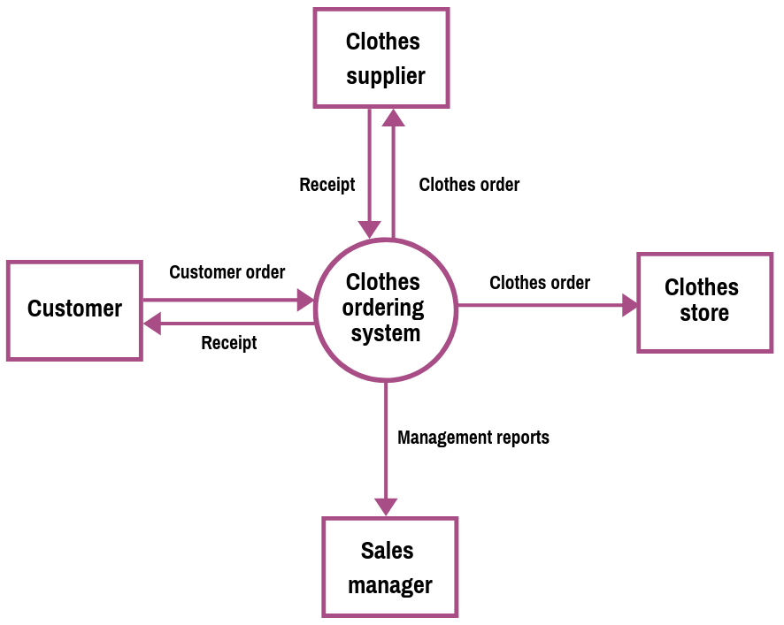
Download the above diagram in PDF
Now, let’s explain how we create the diagram.
Srep1: Define the process.
As it is a context data flow diagram, the process is only one. In our case, it is Clothes Ordering System. Draw a rectangle for the process.
Step 2: Create the list of all external entities.
In our example, the external entities are: Customer, Clothes Store, Clothes Supplier, and the Sales Manager. These are all entities who are involved with our system. Also, now you can draw a rectangle for each of the entities.
Step 3: Create a list of the data flows.
In between our process and the external entities, there are data flows that show a brief description of the type of information exchanged between the entities and the system.
In our example, the list of data flows includes: Customer Order, Receipt, Clothes Order, Receipt, Clothes Order, and Management Report.
Now, connect the rectangles with arrows signifying the data flows.
If data flows both ways between any two rectangles, create two individual arrows.
Step4: It is our diagram.
2. Level 1 data flow diagram: definition and example with explanation
As you saw above context DFD contains only one process and does not illustrate any data store.
This is the main difference with level 1 DFD.
Level 1 DFD breaks down the main process into subprocesses that can then be seen on a more deep level. Also, level 1 DFD contains data stores that are used by the main process.
Steps for creating a context DFD:
- Step1: Define the processes (the main process and the subprocesses).
- Step2: Create a list of all external entities (all people and systems).
- Step3: Create a list of the data stores.
- Step4: Create a list of the data flows.
- Step5: Draw the diagram.
Here is our level 1 data flow example – a decomposition of the Clothes Ordering System illustrated in the context DFD.
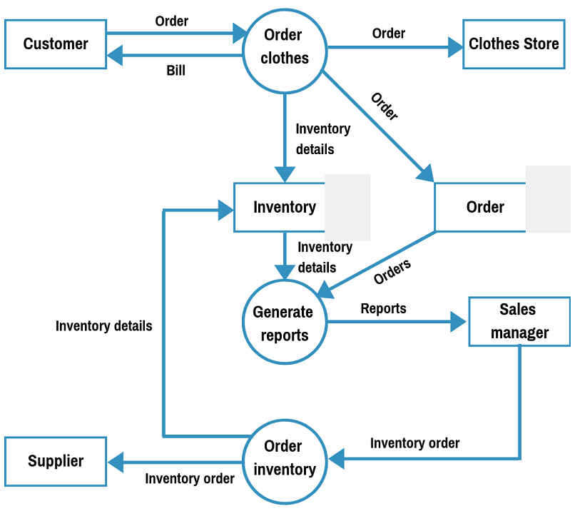
As you see, the above Clothes Order System Data Flow Diagram Example shows three processes, four external entities, and also two data stores.
Here are the steps for creating the level 1 DFD:
Step 1: Define the processes.
The three processes are: Order Clothes, Generate Reports, and Order Inventory.
Step 2: Create the list of all external entities.
The external entities are: Customer, Clothes Store, Sales Manager, and Supplier
Step 3: Create the list of the data stores.
These are: Order and Inventory
Step 4: Create the list of the data flows
Data flows are: Order, Bill, Order, Order, Inventory details, Inventory details, Orders, Reports, Inventory Order, Inventory Order, Inventory details.
Step5: Create the diagram.

